12. ReactJS-HOL

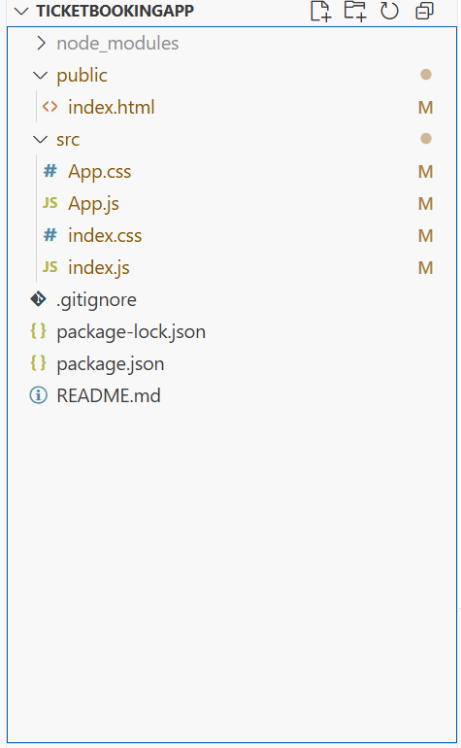

Index.js
import React from "react";
import ReactDOM from "react-dom/client";
import "./index.css";
import App from "./App";

const root = ReactDOM.createRoot(document.getElementById("root"));
root.render(<App />);

App.js
import React, { useState } from "react";
import "./App.css";

// Login Button Component
function LoginButton(props) {
return (
<button onClick={props.onClick}>
Login
</button>
);
}

// Logout Button Component
function LogoutButton(props) {
return (
<button onClick={props.onClick}>
Logout
</button>
);
}

function GuestGreeting() {
return (
<div>
<h2>Please sign up.</h2>
<p>Browse available flights below:</p>
<ul>
<li>✈️ Flight A123 – Chennai → Delhi</li>
<li>✈️ Flight B456 – Mumbai → Bangalore</li>
<li>✈️ Flight C789 – Hyderabad → Kolkata</li>
</ul>
</div>
);
}

function UserGreeting() {
return (
<div>
<h2>Welcome back</h2>
<p>Book your tickets below:</p>
<form>
<label>
Flight Number:
<input type="text" placeholder="Enter flight number" />
</label>
<br /><br />
<label>
Passenger Name:
<input type="text" placeholder="Enter your name" />
</label>
<br /><br />
<button type="submit">Book Ticket</button>
</form>
</div>
);
}
function Greeting(props) {
const isLoggedIn = props.isLoggedIn;
if (isLoggedIn) {
return <UserGreeting />;
}
return <GuestGreeting />;
}

function App() {
const [isLoggedIn, setIsLoggedIn] = useState(false);

const handleLoginClick = () => {
setIsLoggedIn(true);
};

const handleLogoutClick = () => {
setIsLoggedIn(false);
};

return (
<div className="container">
<Greeting isLoggedIn={isLoggedIn} />
{isLoggedIn ? (
<LogoutButton onClick={handleLogoutClick} />
) : (
<LoginButton onClick={handleLoginClick} />
)}
</div>
);
}

export default App;

index.css
body {
margin: 0;
padding: 0;
background-color: #ffffff;
}

App.css
.container {
padding: 30px;
font-family: Arial, sans-serif;
text-align: center;
}

h2 {
font-size: 24px;
font-weight: bold;
margin-bottom: 10px;
}

p {
font-size: 16px;
}

button {
margin-top: 15px;
padding: 8px 16px;
font-size: 14px;
border: 1px solid #ccc;
background-color: #f8f8f8;
cursor: pointer;
border-radius: 4px;
}

button:hover {
background-color: #e6e6e6;
}

ul {
list-style: none;
padding: 0;
}

ul li {
font-size: 16px;
margin: 6px 0;
}

